**Daily Scrum or Standup Meeting**

Team name: Group 8_________________________

Scrum Master: Cole_______________________

Date: 3-29_______________________________

|  |  |  |  |
| --- | --- | --- | --- |
| **Team Member** | **What did you do since the last scrum?** | **What do you plan to do before the next scrum?** | **What obstacles do you have?** |
| Cole | Continued work on admin interface | Continue working on admin interface | Time, API/DB understanding |
| Logan | Worked on figuring out authentication | Continue working on auth | An ocean of very detailed documentation |
| Austin | N/A | N/A | Time |
|  |  |  |  |
|  |  |  |  |

# Burndown

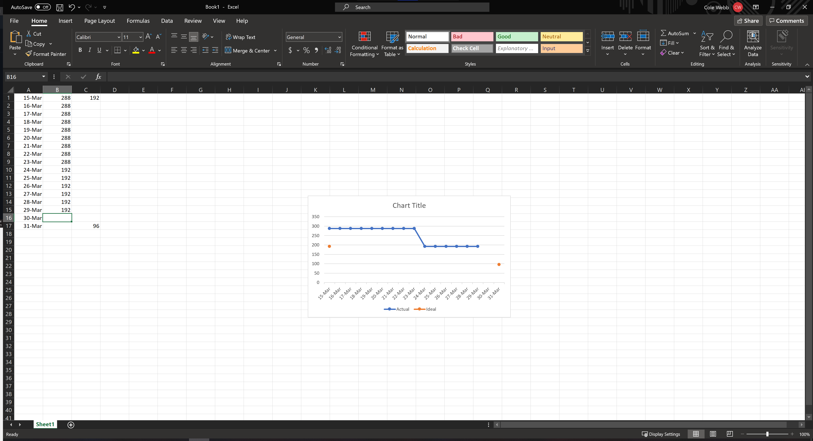

# Screenshot of you project board

